

Mapledene & Queensbridge’s Children’s Centre

Programme of Activities

September 2024 - December 2024



**Wednesday**





**\*0-5 year olds**

**9.00 am – 11.30 am**



**Citizens Advice Bureau**

**10.00 am -1.00 pm**

**(Every 1st Wednesday)**

**Bookstart Corner**



**1.30 pm – 2.30 pm For parents & their 12 – 24 months old children**

**Your child will receive a free book pack!**

**By appointment only**

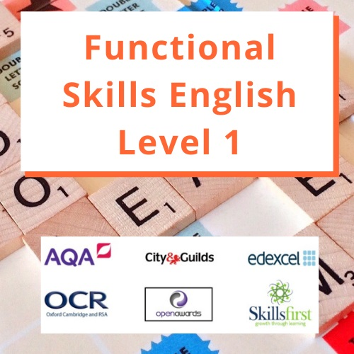

**1.00pm – 3.00pm**



**(Referral only)**

**9.00 am – 5.00 pm**

**Alive and Kicking Football Library at Mapledene**

**Need a football?**

**Borrow one for free! We simply ask that you bring the ball back so that others can enjoy it.**

**Please call to speak to a member of staff**

**Tuesday**



**£1 donation for this session**

**\*0-2 years from**

**9.30 am – 10.15 am**

**\*2-5 years – 5 year olds from**

**10.15 am – 11.00 am**

**Snack time from**

**11.00am – 11.30 am**

**First Steps**

**(Referral only)**

**10 am – 6 pm**

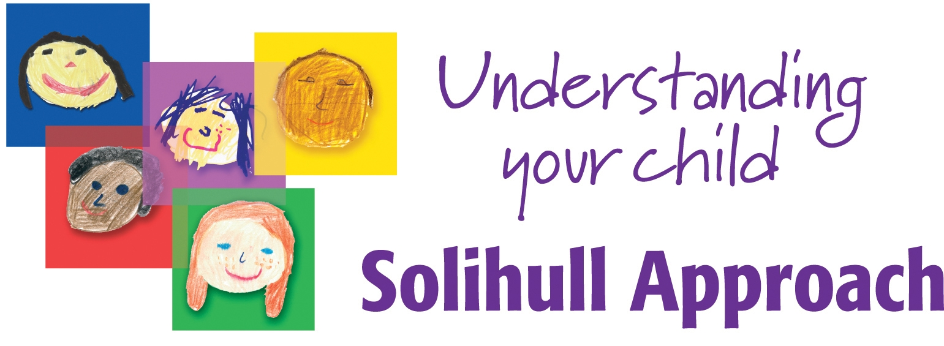

**for children aged 0-5 years old**

**10.00 am - 12.00 pm**

**Starts September 17th – 3rd December**

**(Every Tuesday for 11 weeks)**

**(Please book a space, crèche available**

**6 months – 5 years)**

**Baby Massage**

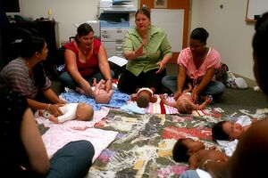

**\*0- Pre-crawling**

**1.30pm-3.00pm**

**Starts 10/09/24 – 08/10/24**

**(5 weeks course)**

**(Please book a space)**



**1.00pm – 3.00pm**

**Monday**





**With Physical Literacy**

**9.00 am - 11.30 am**

**\*0-5 year olds**

**First Steps**

**(Referral only)**

**10 am – 6 pm**



**With Book Library**

**\*0-5 year olds**

**1.00 pm – 3.00 pm**

**Let’s get healthy with HENRY**

[](http://www.google.co.uk/url?sa=i&rct=j&q=&esrc=s&source=images&cd=&cad=rja&uact=8&docid=exgITTpceicyLM&tbnid=6IH2a5D-FweYEM:&ved=0CAUQjRw&url=http://www.bromleyhealthcare.org.uk/find-a-service/healthy-lifestyles-for-you/lets-get-healthy-with-henry&ei=r_XEU_LxL6yY0QXC44GwDw&bvm=bv.70810081,d.ZGU&psig=AFQjCNHQ9eIiEhfM64oLt6FHv3POcBiC4A&ust=1405503129859182)

**1.00 pm – 3.30 pm**

**Starts on 07/10/24 – 02/12/24**

**(8 weeks)**

**(Please book a space, crèche available)**

**FREE Vitamins for pregnant women, new mothers and children up to age 4**  **If you are not in receipt of vitamins please speak to a member of staff.**

**On the 1st Monday of each month, bring fresh fruits to share with others during our Messy play session.** 

**Friday**



**With Bouncy & soft play**

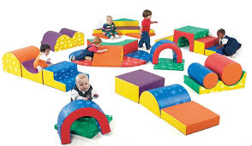

**\*0-5 year olds**

**9.00 am – 11.30 am**

**Functional skills in Maths**



**10am – 12.30pm**

**Come along on the 1st Friday of each month, to our Road safety awareness event.**



**Nia Project**

**Referrals only**

**9.00 am – 5.00 pm**

**Evaluation**

**Have you attended more than three services in Cluster F?**

**If you have, we would love to know your views and ideas. Please see any member of staff to book an evaluation session.**

**Remember… your views do matter!**



**Are you having difficulty providing food for your family?** **If so speak to a member of staff**

**To use our services you must have a child under five years of age and be a Hackney Resident. You will also be asked to register.**

**Thursday**

**Under 18 months**

**Drop-in with Sing & Sign**



**10.00 am – 11.30 am**

**Getting Ready for School**



**Early Literacy Workshops**

**9.00am - 10.00am**

**For parents & their 3-4 year old children**

**Information, Advice & Guidance drop-in**

**10am -11.30am****

**(Every 2nd Thursday of each month)**



**With Toy Library**

**\*0-5 year olds**

**1.00 pm – 3.00 pm**

**Volunteers are always needed**

http://www.vcscymru.org.uk/wp-content/uploads/2013/01/volunteers.jpg**Wouldyou like to gain experience in the workplace to help you when applying for jobs. Please call Miza**

**Come along to our daily Clothes Swap and you won’t be able to stop. Bring in your unwanted clothes and swap them for items you love!**



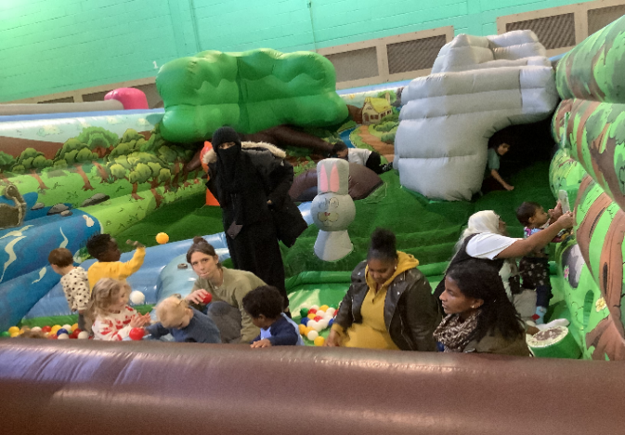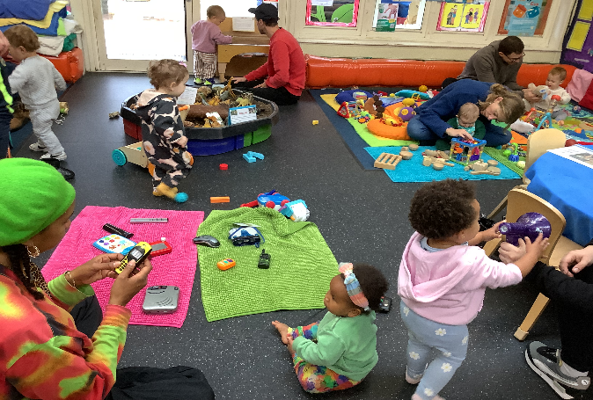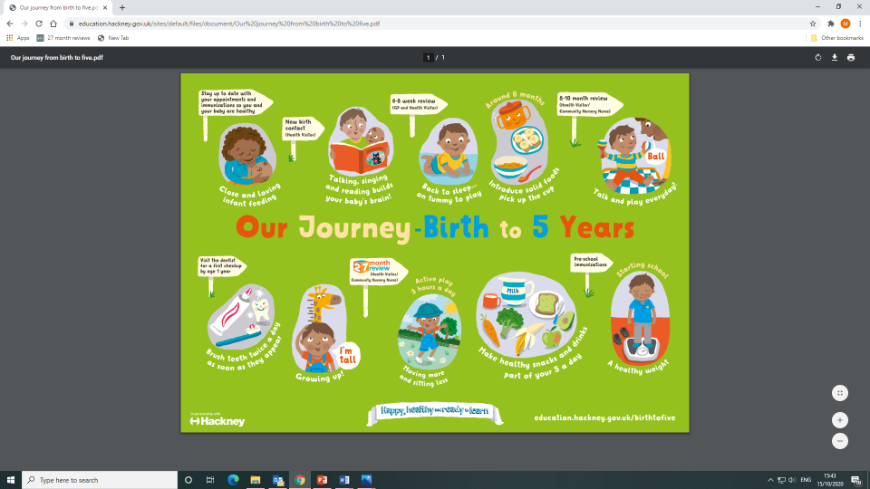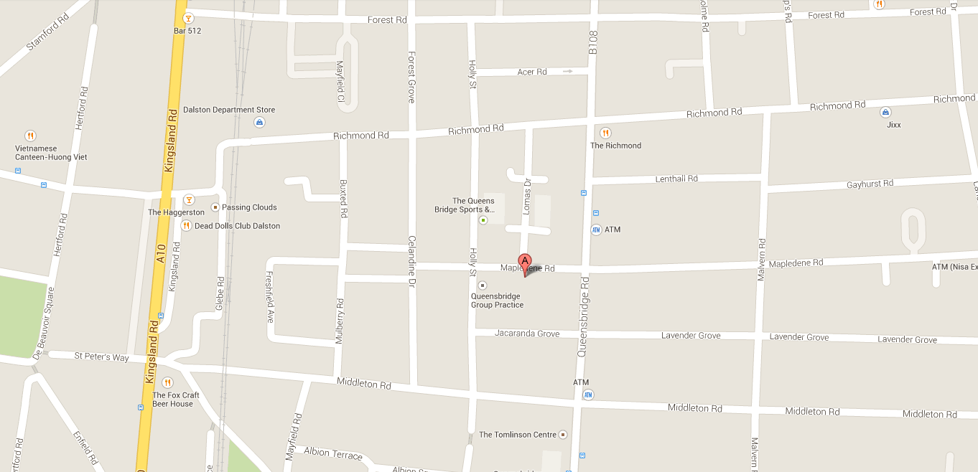

**Working for every child: Follow us on** **@ mapledenecc**

**Five To Thrive**

To

Thrive

**Please scan for programme of activities**

**Mango Room staff:**

**Nasima Begum –**

[**nasima.begum@mapledenecc.co.uk**](mailto:nasima.begum@mapledenecc.co.uk)

**Scarlett Freebairn –**

[**scarlett.freebairn@mapledenecc.co.uk**](mailto:scarlett.freebairn@mapledenecc.co.uk)

**Mariam Ayekoti –**

[**mariam.ayekoti@mapledenecc.co.uk**](mailto:mariam.ayekoti@mapledenecc.co.uk)

**Please scan for direction to the Centre**

**If you or your family require any additional support or advice please contact Pamela or Miza at the Centre on**

**02072498139 or Email pamela.phipps@mapledenecc.co.uk**

[**miza.myers@mapledenecc.co.uk**](mailto:miza.myers@mapledenecc.co.uk)

**Address:**

**54 Mapledene Road, Hackney, London, E8 3LE**

**Serving Families in London Fields & Shoreditch Park**

**Mapledene & Queensbridge Children’s Centre**

**Programme of Activities** **RATED “OUTSTANDING IN ALL AREAS 2019**