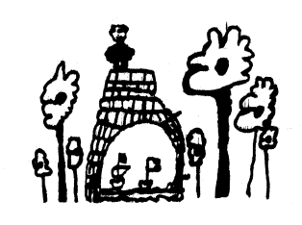

**Key dates for September/December 2024**

Monday 2nd – Tuesday 3rd September **Centre Closed Inset Day**

Friday 4th October **World Teacher’s Day & World Smile Day**

Monday 14th – Friday 18th October **Recycle Week**

Monday 28th October - Friday 1st November **Half Term**

Monday 28th October – Friday 1st November **Parents & Black History Week**

Thursday 31st October **Halloween** Friday 1st November **Diwali**

Monday 4th November **Extended Services Parents Forum** Tuesday 5th November **Guy Fawkes Night**

Wednesday 6th November **Red Book Day**

Friday 8th November **Day-Care Parents Forum, Welcome Breakfast & World Science Day**

Wednesday 13th November **World Kindness Day**

Friday 15th November **Children in Need**

Monday 18th – Friday 22nd November **Road Safety Week**

Monday 25th November – Friday 6th December **Parent Teacher Consultations**

Wednesday 11th December **Christmas Dinner**

Friday 13th December **Christmas Party/Christmas Jumper Day**

Monday 16th – Friday 20th December **Hanukkah**

Tuesday 24th December 2024 – Wednesday 1st January 2025 **Centre Closed for Christmas Holiday**

**Mapledene Termly News**

**Summer Issue**

**2024**

**Termly News**

The summer term is coming to an end, we would firstly like to thank you all for your continuous support. Without which we would not be able to offer your children all the extra curricular activities. We thank you also for the generous end of term gifts and kind words. Mapledene had their Ofsted Inspection on Wednesday 31st July, the outcomes will be published for you all to read mid-September. It has been a busy summer term and we wish a fond farewell to Maples children leaving to start their new learning journey at school. During the two-week centre closure, major works will be carried out to almost all areas of the building. All rooms will have new kitchenets, old stained carpets will be replaced together with the ageing lino. We ask that in the new term to protect the new flooring, that you leave all bikes and scooters in the shed and collect them on your way out.

Fees

The new fee structure will start on the 2nd September 2024. Invoices get emailed on the 1st Monday of each month. If you have any queries about your invoice or the banding fee you are on please contact Serap on [serap.ciftci@mapledenecc.co.uk](mailto:serap.ciftci@mapledenecc.co.uk) who will be happy to answer any questions or queries.

Visit our web page at [www.mapledenechildrenscentre.co.uk](http://www.mapledenechildrenscentre.co.uk) Instagram  @ mapledenecc

**Our Curriculum**

Our children show curiosity to learn and will interact with other people and the world around them in different ways. Staff recognise the four principles of learning linked to the Early Years Foundation Stage (EYFS) and ensure the children’s learning environment includes the unique child, positive relationships, enabling environment as well as learning and development. Staff will observe and understand each child’s development and learning. Be sensitive and responsive to your child’s individual needs, feelings and interests whilst supporting your child’s own efforts and independence. Staff will offer stimulating resources and spaces inside and outside that is relevant to all the children’s cultures and communities. The autumn term brings a new overall theme linked to Understanding the World which is designed to develop critical thinking, problem-solving, and creativity. The topic will build on the children’s previous knowledge and prepares them for future learning.

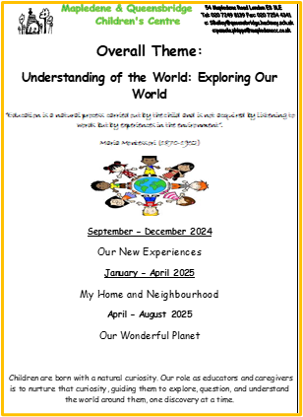

Planning allows us to tailor learning experiences to meet the diverse needs of each child, accommodating different learning styles, abilities, and interests. It helps in setting specific, achievable goals for each child, ensuring that they can progress at their own pace. It also help’s staff to keep track of your children’s progress. "Understanding the World" is a key area of learning in your child’s education that helps children make sense of their environment and the wider world.

**Apples & Seedlings** 

Apples Children will be welcoming our new friends this term. We will be helping the children settle and build relationships with new peers and staff. We will continue with small focus groups, building on language skills. We will use our emotions board to help with understanding new feelings as we explore our learning environment. For our new topic ‘New Experiences’, we plan on having a picnic in the park, a tea party and a fancy-dress day. We will be exploring our new learning garden area, where we plan on having regular music and dance sessions on our new stage.

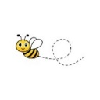

Butterfly Images | Free Photos, PNG Stickers, Wallpapers & Backgrounds -  rawpixel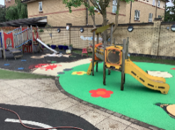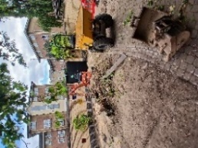

**Maples** 

Maples children will be supported with their transition from Palms room. They will be focusing on the topic “New Experiences” where this will give the children the opportunity to talk about what new experiences, they have had during their summer break with their families and carers and look at what new experiences they will encounter in Maples room. They will have the opportunity to vote on things such as what their home corner can be turned into or what book to read at story time. Collectively, Maples children will have circle time discussions linked to topics of their interests and share holiday and weekend news. Maples children will be looking at families and how they are different. During the term, Maples will be visiting local areas around Hackney to continue to further their development and experience new changes. We will also be supporting them with understanding of the world and how their community helps them by taking them on a cultural walks and celebrating all the different festivals and learning new experiences.

**The Learning Garden update**

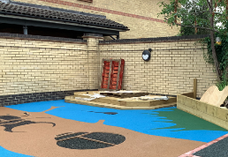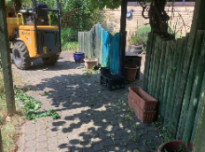ppppp

The learning garden has been closed for the children due to major construction works that are being carried out. New flooring has been put down to replace the old hazardous one in the main garden. The learning garden will be open soon and has areas for the children to continue to plant and grow their own vegetables. Outdoor activities will be set up in the new area to support learning.

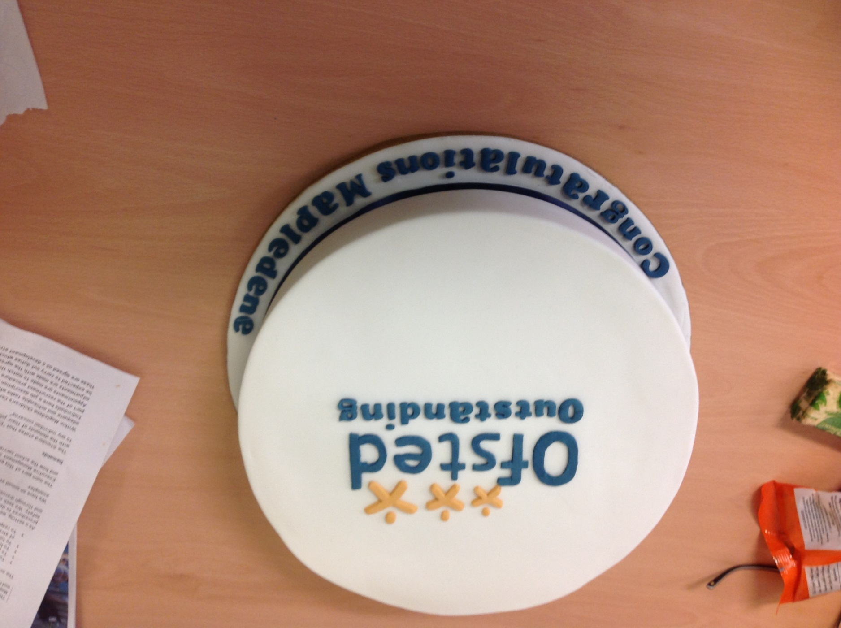

**Palms**

Palms room will have the older children in the room to support the new children, to become familiar with the routine and adjust to their new play environment. Keyworker groups will take place to help support children with transitions and being in a much bigger space and make bonds. In keeping with the topic of the term we will use our core books to initiate conversations and awareness of different experiences such as new siblings, visiting the dentist and holidays. Visits will be arranged for the children to go to our local dentist and doctors’ surgeries. We will be using our updated learning garden space to start planting foods for the children to observe growth and learn how to look after the plants. Extending this experience they will use the food to help make snacks or meals for them to eat.

**Signing in and Out**

Please remember to always sign your children in and out of their room base as part of our safeguarding procedure. Your signing in and out sheet can be found on entry into your child’s room on the wall under the clock.

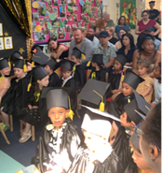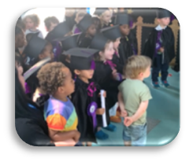

Palms Room

**End of Year Graduation**

**No Scooting or Running inside the building**

We kindly ask you to remind your children to not scoot or run inside the building. The walk ways are in constant use by others and could cause a serious accident if collisions occur. When collecting your children from their room base, please leave their scooters or bikes in the shed and pick up as you leave. The same applies on drop off, we ask you to please leave your child’s scooter in the shed before entering the building.

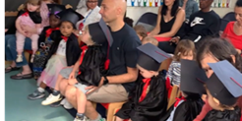



**Extended Services **

In Mango room we listened to your feedback regarding serving hot food at some snack times during the week. This has become a good success, in order to keep this up we ask for you to make a small donation of £1 per session. Our Autumn programme of activities is now available online or you can pick up a copy at the centre. Our last ‘Getting Ready for School’ early literacy workshop was well attended. We are running another session for parents and their 3–4-year-old children from 9am – 10am on Thursdays in the new term. You are welcome to book a space for Baby Massage for 0-pre-crawlers. The sessions will start on 10th September for 5 weeks ending on 8th October 2024 from 1.30pm – 3pm each Tuesday. If you need support with understanding your child, come to the Solihull Approach for children aged 0-5 years old from 10am – 12pm starting 3rd October – 12th December 2024. This course comes with creche available, to book your place please see a member of Mango room staff.

Maples Room

Apples & Seedlings

**Staffing** 

We wish Ethan good luck as he leaves us for a career change. We wish Izzy good luck on starting her maternity leave. In September Apples and Seedlings children will be supported by Liz (Room Leader) along with Rumena, Mirembe, Olu, Tannaee and Tola. Palms room children will be supported by Merlene (Room Leader) with Kayland, Krystal, Jack, Tanya and Georgina. Maples children will be supported by Krishna (Room Leader) alongside Yasmin and Jasmin. Mango room will be led by Nasima (Room Leader), with Mariam and Scarlett. Kitchen is run by Chantelle who is supported by Maseray and Deslin. We also need to recruit a practitioner for Maples Room. The recruitment process will take place in September 2024.

**Choosing Primary Schools**

Usually at the start of the autumn term, parents of children transitining to Maples room in September. Will receive information about looking for schools. You must apply through your local authority for a place at a primary school, even if it is linked to your child’s current nursery. You must apply for a primary school place a year before your child can start school. Click on the link for more information <https://education.hackney.gov.uk/content/when-will-my-child-start-school> help will be at hand for those who need support with their application.

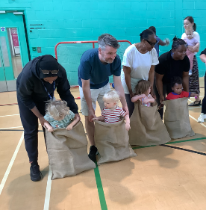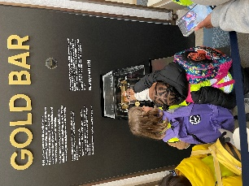

**Extra-Curricular Activities**

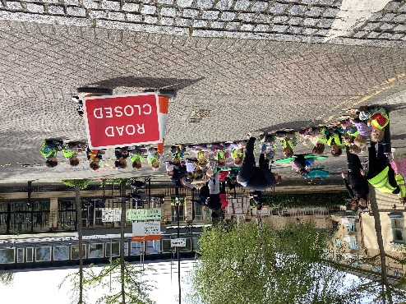

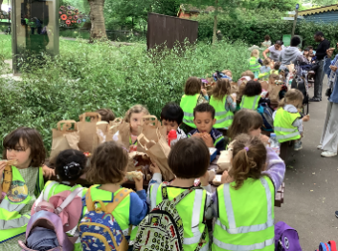

**Children’s Blue Bags**

We ask all our parents and carers to please fill their child’s blue bag with spare clothes. Each child is given a blue Mapledene bag to use whilst here. The bag belongs to Mapledene, so please ensure they are returned empty before your child leaves the centre for school. Please also check the bag regularly to ensure there is sufficient underwear, especially for children who are toilet training.

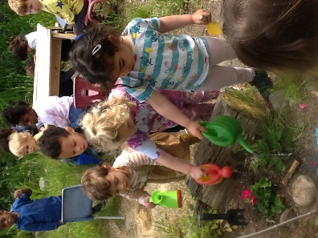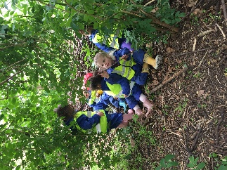

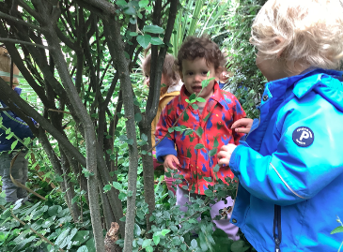



**Please contact the office immediately if you have made changes to your contact details.**

**Useful links**

Hackney Children & Family Hubs <https://education.hackney.gov.uk/content/hackney-children-and-family-hubs>

Hackney’s 10x10 Programme <https://education.hackney.gov.uk/content/10x10-programme>

Your Child’s Journey <https://education.hackney.gov.uk/content/your-childs-journey-birth-five>

**Clothes Swop**

If your child has outgrown their clothes, shoes, toys or books which are all in good condition. You are welcome to bring them, to our clothes swop set up in the front foyer. The idea of clothes swop, is to leave an item and take an item, this is a good way to recycle. The space is limited so please think about the size and shape of items you are leaving.