
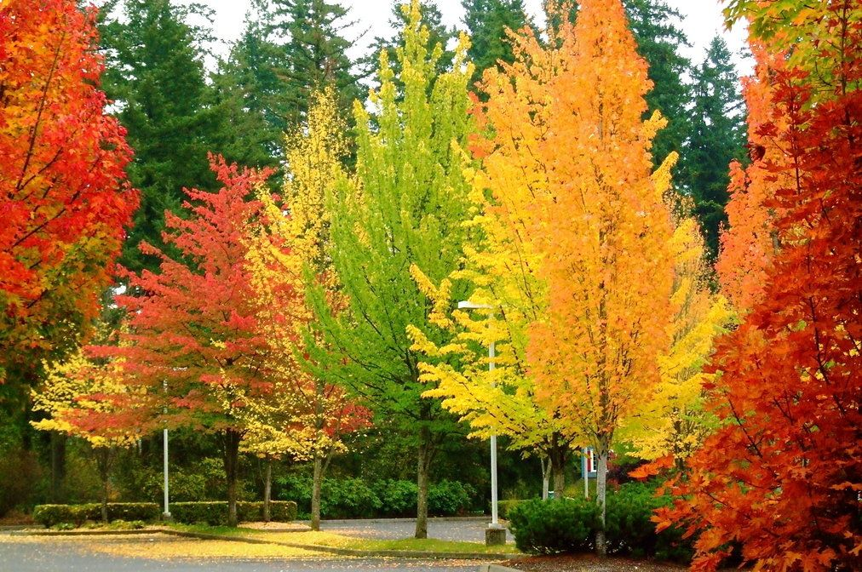
Autumn Term Events at Mapledene
4th September 2024
Hi Everyone
We know you are all very busy so we wish to give you plenty of notice of all our forthcoming events during the autumn term. Please make a note of these dates in your diary and remember. Please note the following:
Date | Event | Times
Monday 14th – Friday 18th October 2024 | Recycle Week | Celebrating in all rooms
Friday 4th October 2024 | World Teachers Day | Celebrating in all rooms
Friday 4th October 2024 | World Smile Day | Celebrating in all rooms
Monday 28th October – Friday 1st November 2024 | Parents & Black History Week | Celebrating in all rooms
Thursday 31st October 2024 | Halloween | All rooms
Tuesday 5th November 2024 | Bonfire/Fireworks | All rooms
Friday 8th November 2024 | Welcome Breakfast | 9.00am – 11.30 am
Friday 8th November 2024  Monday 4th November 2024 | Day – Care Parents Forum  Extended Services Parents Forum | Day Care: 9.00am – 10am  Mango Room 10.45am – 11.30am
Wednesday 6th November 2024 | Red Book Day | 9.00am – 11.30 am
Friday 1st November 2024 | Diwali | All rooms
Friday 8th November 2024 | World Science Day | All rooms
Wednesday 13th November 2024 | World Kindness Day | All rooms
Friday 15th November 2024 | Children in Need | 9am – 12noon (whole centre)
Monday 18th – Friday 22nd November 2024 | Road Safety Week | All rooms
Monday 16th December – Friday 20th December 2024 | Hanukkah | Celebrating in all rooms
Wednesday 11th December 2024 | Christmas Dinners | Celebrating in all rooms
Friday 13th December 2024 | Christmas Parties/Christmas Jumper Day | Celebrating in all rooms
Monday 23rd December 2024 | Last day of term | Centre closes at 2 pm
Tuesday 24th December 2024 – Wednesday 1st January 2025 | Christmas Holiday | Holiday closure
Thursday 2nd & Friday 3rd January 2025 | Inset Training | Centre is Closed
Monday 6th January 2025 | Children back | Centre re-opens 8am as normal

Many thanks
Pamela Phipps
Centre Manager

