[](http://www.google.co.uk/url?sa=i&rct=j&q=blue+and+green+background&source=images&cd=&cad=rja&docid=niHbgeNlckTVgM&tbnid=G4YyyrnA9phnFM:&ved=0CAUQjRw&url=http://webdesignbackgrounds.blogspot.com/&ei=m-OIUZ-BIKWa1AW54oGIDg&bvm=bv.45960087,d.d2k&psig=AFQjCNH6Nsj1gyAdi2A9R4718pxccBzn-Q&ust=1368012047956919)

**Tuesday 18th February**



**£1 donation for this session**

**\*0-30 months old from**

**9.00 am – 9.45 am**

**\*30 months – 8 year olds from 9.45 am – 10.30 am**

**\*Outdoor Play**

**10.30 am – 11.00 am**

**Snack time from**

**11.00 am – 11.30 am**



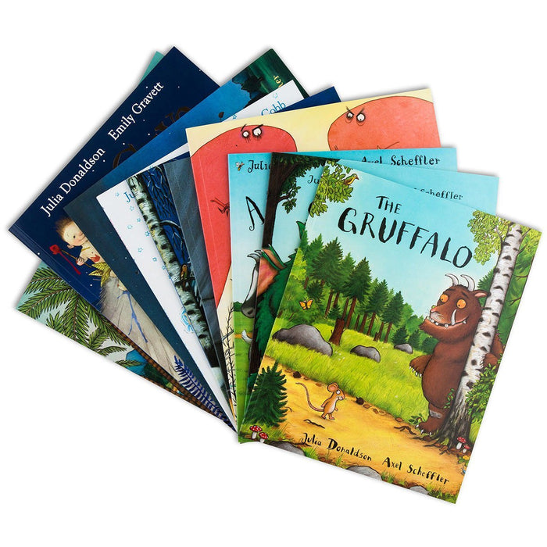

**With Book/Toy Library**

**1.00 pm – 3.00 pm**

**\*0-8 year olds**

**Volunteers are always needed**

http://www.vcscymru.org.uk/wp-content/uploads/2013/01/volunteers.jpg

**Would you like to gain experience in the workplace to help you when applying for jobs. Please call and ask to speak to Miza**

**Monday 17th February**



**\*0-8** **year olds**

**9.00 am – 11.30 am**

**Setting Limits and Understanding Your Child’s Behaviour in the Early Years**

**Workshop delivered by**

**DR Susie Haynes**



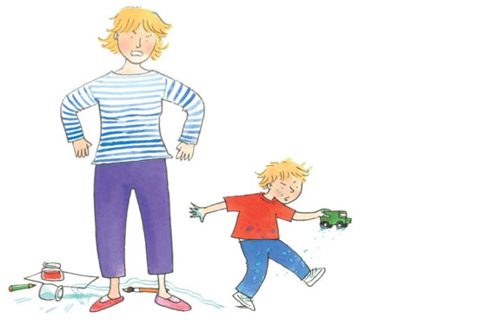

**1.00 pm – 3.00 pm**

**Crèche provided for children aged**

**\*6 months – 5 years old please book a space**



**Are you having difficulty providing food for your family?**

**If so speak to a member of staff**

**Friday 21st February**





**9.00 am - 11.30 am**

**\*0-8 year olds**

**Bouncy castle and soft play**

**Come along to our daily Clothes Swap and you won’t be able to stop. Bring in your unwanted clothes and swap them for items you love! **



[](https://www.google.co.uk/url?sa=i&rct=j&q=&esrc=s&source=images&cd=&cad=rja&uact=8&ved=0ahUKEwjayIbhxdDRAhXCFywKHdMuApoQjRwIBw&url=https://clipartfest.com/categories/view/ab6c963a205a244d3e351564d84e581c92ac213d/valentines-day-clipart-for-children.html&psig=AFQjCNE-IIcBPCgCHL637fijvEyamznd8g&ust=1484994750943052)



**RATED**

**“OUTSTANDING” IN ALL AREAS 2024**

**Thursday 20th February**

**A trip to Natural History Museum**



**9.00 am – 2.00pm**

**\*0-8 year olds**

**Please bring an oyster card & a packed lunch. We leave together from the centre**



**Remember have fun!**[](http://www.google.co.uk/url?sa=i&rct=j&q=&esrc=s&source=images&cd=&cad=rja&uact=8&ved=0ahUKEwiejaKVqqfLAhVB_w4KHa_oBb0QjRwIAw&url=http://www.worldanimalfoundation.net/farm_animals.html&psig=AFQjCNGLqt1smkTeg-T1Eqn0a56jhuqJfg&ust=1457191143925162)



**Wednesday 19th February**

[](http://www.littlecooks.co.nz/)

**“Cauliflower and Potato Bake“**

**[](http://www.google.co.uk/imgres?q=cooking&hl=en&biw=1024&bih=571&tbm=isch&tbnid=pM4ugaIgiCShSM:&imgrefurl=http://softsupplier.com/cooking-apps-to-replace-cookbooks-114966/&docid=2CJ5aqedu268uM&imgurl=http://softsupplier.com/wp-content/plugins/jobber-import-articles/photos/115177-cooking-apps-to-replace-cookbooks-2.gif&w=353&h=360&ei=-OdQT4vFPIa48gPPm-DwBQ&zoom=1&iact=rc&dur=156&sig=113117572567354406729&page=2&tbnh=120&tbnw=118&start=16&ndsp=20&ved=1t:429,r:9,s:16&tx=14&ty=67)**

**\*0-8 year olds**

**9.00 am – 11.30 am**

[](http://www.google.co.uk/url?sa=i&rct=j&q=&esrc=s&source=images&cd=&cad=rja&uact=8&ved=0CAcQjRxqFQoTCNjV-ZqhlckCFQk6FAodgqgLeg&url=http://www.horshamlifesavingclub.co.uk/baby/&psig=AFQjCNHn1KkJxR9HGpj8MbwVw5WJ_HOcwg&ust=1447773971796518)

**Workshop for Parents and Carers with crèche provided**



**\*0-5 year olds**

**1.30 pm – 3.00 pm**

**Please book as there are limited space**

**FREE Vitamins for pregnant women, new mothers and children up to age 4** **If you are not in receipt of vitamins please call the centre to speak to a member of staff.**



Mapledene’s February Half Term Programme of Activities 2025

---------------------------

**Mapledene & Queensbridge Children’s Centre**

**54, Mapledene Road, Hackney E8 3LE Tel: 020 7249 8139**

**For further information or support please contact Pamela or Miza at the centre on 020 7249 8139 or** [**pamela.phipps@mapledenecc.co.uk**](mailto:pamela.phipps@mapledenecc.co.uk)[**miza.myers@mapledenecc.co.uk**](mailto:miza.myers@mapledenecc.co.uk)

**To use our services you must have a child under five years of age and be a Hackney Resident. You will also be asked to register.**

**Mapledene & Queensbridge Children’s Centre**

**54, Mapledene Road, Hackney E8 3LE Tel: 020 7249 8139**