

**Monday 28th**

**October**

**Messy Play with a** **Creative Workshop for Black History Season**



**\*0-8 year olds**

**9.00 am – 11.30 am**



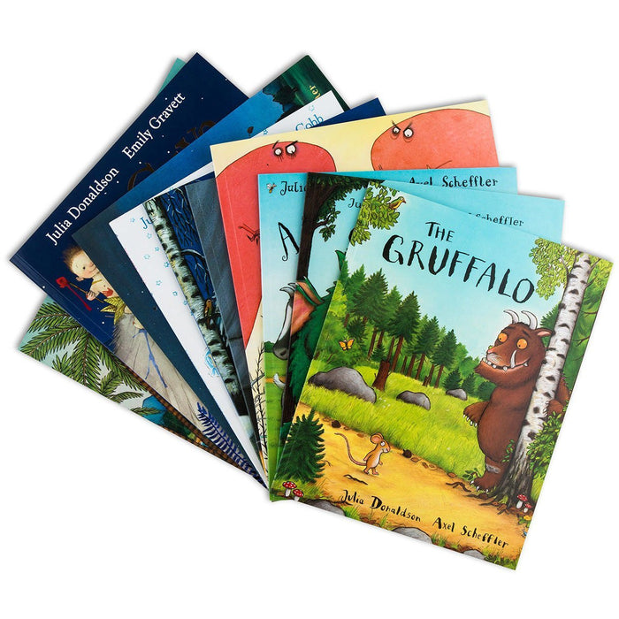

**With Book/Toy Library**

**\*0-8 year olds**

**1.00 pm – 3.00 pm**

**Setting Limits and Understanding Your Child’s Behaviour in the Early Years**

**Workshop delivered by**

**DR Susie Haynes**



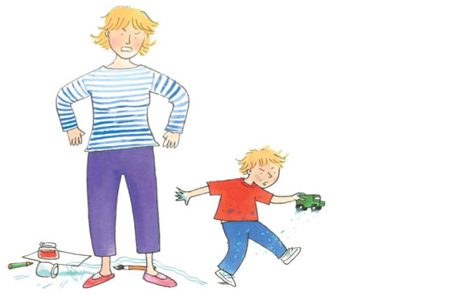

**1.00 pm – 3.00 pm**

**Crèche provided for children aged**

**\*6 months – 5 years old please book a space**



**Wednesday 30th October**

**Little Cooks**

****[](http://www.123rf.com/photo_10892109_international-foods-and-cuisines-of-the-world-represented-by-a-restaurant-chef-hat-and-flags-of-coun.html)****

**“From around the world”**

**\*0-8 year olds**

**9.00 am – 11.30 am**

**Stay & Play witH fancy HALLOWEEN costumes**

 [](http://www.google.co.uk/url?sa=i&rct=j&q=&esrc=s&source=images&cd=&cad=rja&uact=8&ved=0CAcQjRw&url=http://www.letscelebrateparties.com.au/costumes-fancy-dress-c-58/&ei=_PWUVcuYDovX7Qa40ZfwAg&bvm=bv.96952980,d.ZGU&psig=AFQjCNGXN-TSAdDdvimuEaoU7U9pHcENdg&ust=1435911369199680)

**Come and have fun and bring your Trick or Treat Bag!**



**\*0-8** **year olds**

**1.30 pm – 3.00 pm**



**Are you having difficulty providing**

**food for your family?**

**If so call the centre to speak to Miza or Pam**

**FREE Vitamins for pregnant women, new mothers and children up to age 4** **If you are not in receipt of vitamins please call the centre to speak to a member of staff.**



**Tuesday 29th**

**October**

**Around the world in music**

[](http://www.google.co.uk/url?sa=i&rct=j&q=&esrc=s&source=images&cd=&cad=rja&uact=8&ved=0CAcQjRw&url=http://www.mpsaz.org/mesa/staff/bravilesviey&ei=FzuRVazOM6eR7Aauv6qoBA&bvm=bv.96783405,d.ZGU&psig=AFQjCNFGTIMVOmQuZZ0meuhlFnrc-S7j7A&ust=1435667517000421)



**£1 donation for this session**

**\*0-30 months from**

**9.00am – 9.45am**

**\*30 months – 8 years old from 9.45am – 10.30am**

**Snack time from**

**11.00am – 11.30am**

**Volunteers are always needed**

http://www.vcscymru.org.uk/wp-content/uploads/2013/01/volunteers.jpg

**Would you like to gain experience in the workplace to help you when applying for jobs. Please call and ask to speak to Miza**



**Do you have a child aged**

**12-24 months? Come and speak to Nasima, Mariam or Scarlett to join our Bookstart Corner programme.**

**Friday 1st**

**November**



**With Bouncy castle and soft play**



**9.00 am – 11.30am**

**\*0-8 years old**



**Come along to our daily Clothes Swap and you won’t be able to stop. Bring in your unwanted clothes and swap them for items you love!**







**Thursday 31st**

**October**

**A Trip to**



**9.30 am – 2.30pm**

**\*0-8 year olds**

**Please bring an oyster card & a packed lunch**



**Remember have fun!**[](http://www.google.co.uk/url?sa=i&rct=j&q=&esrc=s&source=images&cd=&cad=rja&uact=8&ved=0ahUKEwiejaKVqqfLAhVB_w4KHa_oBb0QjRwIAw&url=http://www.worldanimalfoundation.net/farm_animals.html&psig=AFQjCNGLqt1smkTeg-T1Eqn0a56jhuqJfg&ust=1457191143925162)

**Do you have a child aged**

**3-4 years old? Come and speak to Nasima, Scarlett or Mariam to join our REAL project that supports your child with school readiness.**



**2 year old Childcare Surgery**

[](https://www.google.co.uk/url?sa=i&rct=j&q=&esrc=s&source=images&cd=&cad=rja&uact=8&ved=0CAcQjRw&url=https://achildgrows.com/blog/2010/10/school-holiday-workshops-playgroups-and-family-yoga-bija-kids/&ei=rMKHVbHYNIetsAH5o4HwDg&bvm=bv.96339352,d.bGg&psig=AFQjCNGcsB0BZwCwUDLVsneZhOXOkNkfVw&ust=1435046867467450)

**Please call the centre number for an eligibility check.**



**RATED**

**“OUTSTANDING” IN ALL AREAS 2024**



**Are you having difficulty providing food for your family?** **If so speak to a member of staff**

Mapledene’s Parents and Black History Week Programme of Activities 2024





