

**Monday**





**With Physical Literacy**

**9.00 am - 11.30 am**

**\*0-5 year olds**

**First Steps**

**(Referral only)**

**8.00 am – 5.00 pm**

**Baby Massage**



**\*0- Pre-crawling**

**1.30 pm-3.00 pm**

**Starts 20/01/25 – 17/02/25**

**(5 weeks course)**

**(Please book a space)**

**On the 1st Monday of each month, bring fresh fruits to share with others during our Messy play session.** 

**To use our services you must have a child under five years of age and be a Hackney Resident. You will also be asked to register.**

**First Aid for parents/carers**

**Tuesday 18th March 2025 (AM)**

**Please call the centre to book a space.**

**(No creche spaces)**

**Thursday**

**Under 18 months**

**Drop-in with Sing & Sign**



**10.00 am – 11.30 am**



**\*For 1 & 2 year olds with**

**Bookstart Corner**

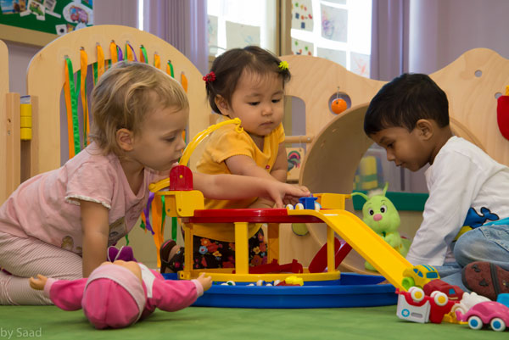

**1.00 pm – 3.00 pm**

**Speech & Language**



**(Referrals only)**

**9.00 am – 5.00 pm**

**NCFE L3 Certificate in Adult Social Care course**



**10.00 am – 2.30 pm**

**Volunteers are always needed**

http://www.vcscymru.org.uk/wp-content/uploads/2013/01/volunteers.jpg**Wouldyou like to gain experience in the workplace to help you when applying for jobs. Please call Miza**

**Alive and Kicking Football Library at Mapledene**

**Need a football?**

**Borrow one for free! We simply ask that you bring the ball back so that others can enjoy it.**

**Please call to speak to a member of staff**

**Wednesday**





**\*0-5 year olds**

**9.00 am – 11.30 am**



**Citizens Advice Bureau**

**10.00 am -1.00 pm**

**(Every 1st Wednesday)**



**Early Bird Programme**

**9.30 am – 12.00 pm**

**By Referral Only**



**1.00pm – 3.00pm**



**(Referral only)**

**9.00 am – 5.00 pm**



**Are you having difficulty providing food for your family? If so speak to a member of staff**

**\*A £1 donation would be greatly appreciated**

**Tuesday**



**With Rachel**

**£1 donation for this session**

**\*0-2 years from**

**9.00 am – 9.45 am**

**\*2 – 5 year olds from**

**9.45 am – 10.30 am**

**Outdoor Play**

**10.30 am – 11.00 am**

**Snack time from**

**11.00am – 11.30 am**

**First Steps**

**(Referral only)**

**8.00 am – 5.00 pm**

**FREE Vitamins for pregnant women, new mothers and children up to age 4**  **If you are not in receipt of vitamins please speak to a member of staff.**



**1.00 pm – 3.00 pm**

**Evaluation**

**Have you attended more than three services in Cluster F?**

**If you have, we would love to know your views and ideas. Please see any member of staff to book an evaluation session.**

**Remember… your views do matter**

**Friday**



**With Bouncy castle & soft play**



**\*0-5 year olds**

**9.00 am – 11.30 am**

**Functional skills in Maths**



**10.00 am – 2.30 pm**

**Come along on the 1st Friday of each month, to our Road safety awareness event.**



**Come along to our daily Clothes Swap and you won’t be able to stop. Bring in your unwanted clothes and swap them for items you love! **

**Nia Project**

**Referrals only**

**10.00 am – 4.30 pm**

**\*\* Last admission for**

**AM session – 10.30am**

**PM session – 2.00pm**

**Holiday closure:**

**Good Friday 18th April 2025**

**Easter Monday 21st April 2025**

**INSET Day – Tuesday 22nd April 2025 CENTRE CLOSED**

Programme of Activities

January 2025 - April 2025

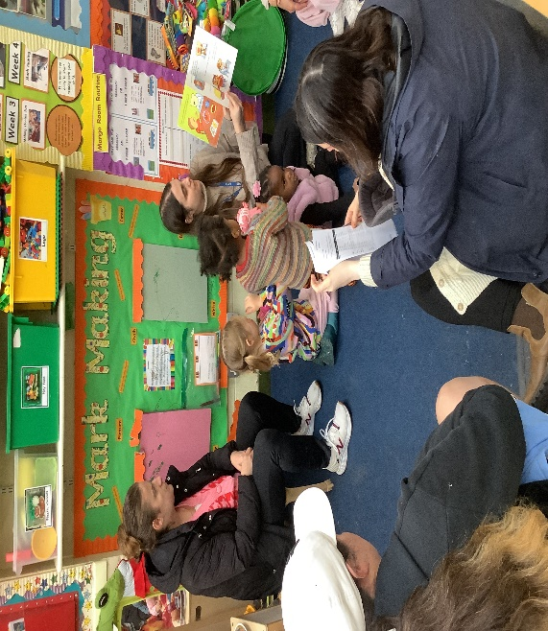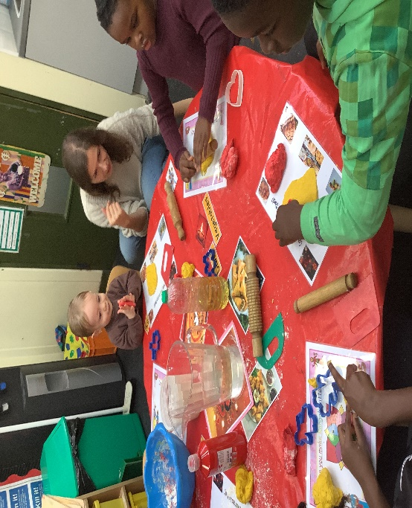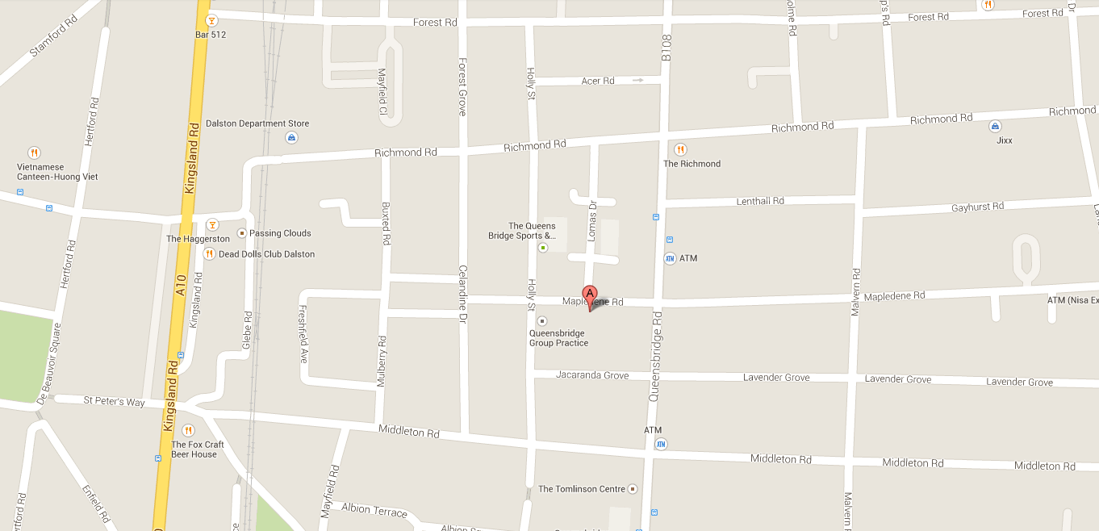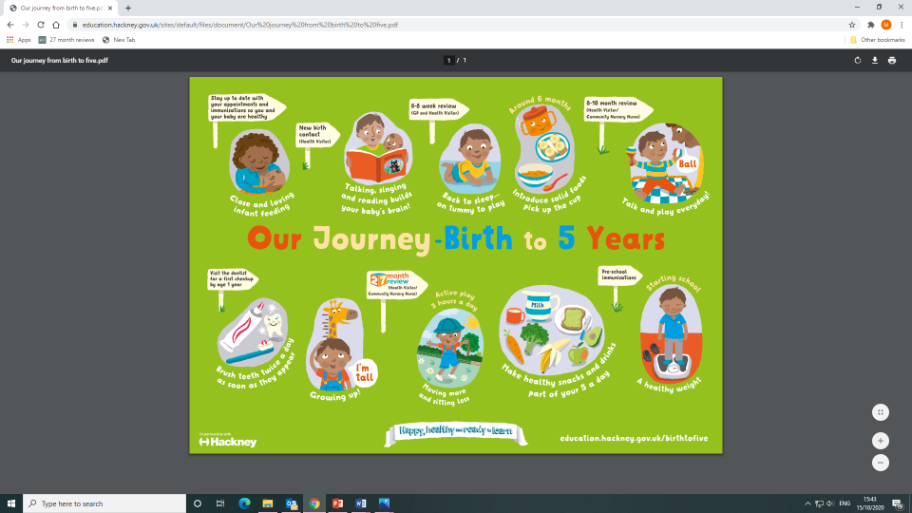

**Five To Thrive**

To

Thrive

**Working for every child: Follow us on** **@ mapledenecc**

**Address:**

**54 Mapledene Road, Hackney, London, E8 3LE**

**Serving Families in London Fields & Shoreditch Park**

**Please scan for direction to the Centre**

**Please scan for programme of activities**

**If you or your family require any additional support or advice please contact Pamela or Miza at the Centre on**

**02072498139 or Email: pamela.phipps@mapledenecc.co.uk**

[**miza.myers@mapledenecc.co.uk**](mailto:miza.myers@mapledenecc.co.uk)

**Mango Room staff:**

**Nasima Begum –**

[**nasima.begum@mapledenecc.co.uk**](mailto:nasima.begum@mapledenecc.co.uk)

**Scarlett Freebairn –**

[**scarlett.freebairn@mapledenecc.co.uk**](mailto:scarlett.freebairn@mapledenecc.co.uk)

**Mariam Ayekoti –**

[**mariam.ayekoti@mapledenecc.co.uk**](mailto:mariam.ayekoti@mapledenecc.co.uk)

**Programme of Activities** **RATED “OUTSTANDING IN ALL AREAS 2024**